**Submitted By: Nasim Mahbub**

Roll: 1809042

**Abdulla Al Jehan** Roll: 18090044

Date of Submission: 27.12.2022



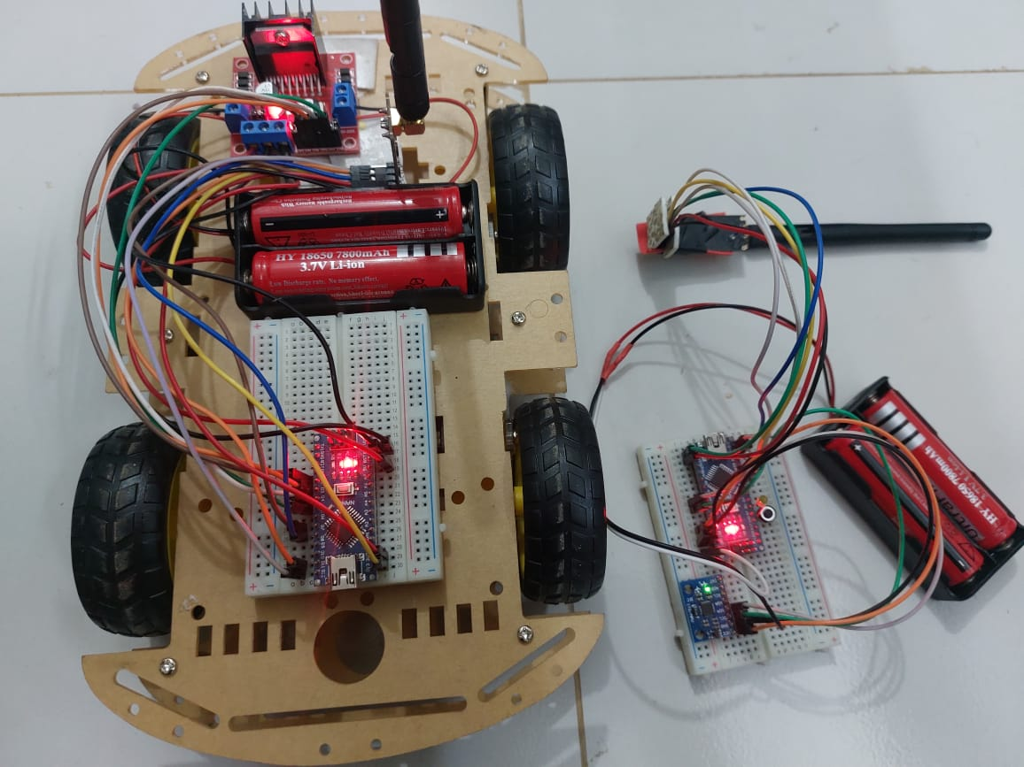

**Department of Electronics and Communication Engineering**

Course: ECE 3200

Arduino based Hand gesture control car

**Project Supervisor:**

**Dr. Md. Faruque Hossain**  
Professor  
Department of Electronics and Communication Engineering

**CONTENTS**

* Objective
* Introduction
* Theory
* Apparatus
* Circuit diagram
* Working principles
* Cost Analysis
* Applications
* Advantage
* Disadvantage
* Limitation
* Discussion
* Conclusion
* Reference

**Objective:**

* to build a car that can be controlled by gesture wirelessly
* to present the control of the robot utilizing the accelerometer with the assistance of human hand gesture
* to control motions of the car by wearing controller glove and performing predefined gestures

**Introduction:**

Robots are controlled utilizing hand gestures since robots need some assistance whether it might be any function, without human robots cannot be worked. The primary reason for utilizing hand gestures is that it gives an increasingly schematic method for controlling the robot and with this feature, the robot can be utilized as a wheelchair or as a spy robot, or for watchfulness. A ‘GESTURE’ is an activity that needs to pass some snippet of data. As human hand gestures are normal, with the assistance of wireless communication, it is simpler to collaborate with the robot in a progressively well-disposed way. The robot's development depends upon the gestures made by hand.

After the transformation of robots into different segments, individuals are attempting to control them more precisely and easily. In the course of recent years, individuals are finding a less difficult approach to speaking with robots so as to upgrade their commitment to our day-to-day life. People and robots are combining like never before to defeat new difficulties. From the beginning times, it was one of the primary targets to control the robot easily and comfortably. So rather than using regular remotes, it is better to use hand motion or hand gestures in order to control a robot. These days hand motion or gesture innovation is being utilized all the more unexpectedly in numerous divisions. A robot is a smart machine that is advised by a PC application to perform different exercises and organizations. It accepts a fundamental activity in mechanization over all parts like manufacturing, military improvement, and clinical and to forward.

**Theory:**

An RF transmitter module is a small PCB   capable of transmitting a radio wave and modulating that wave to carry data. Transmitter modules are usually implemented alongside a microcontroller which will provide data to the module which is transmitted. RF transmitters are usually subject to regulatory requirements which dictate the maximum allowable transmitter power output, harmonics, and band edge requirement.

An RF Receiver module receives the modulated RF signal, and then it demodulates . There are two types of RF receiver modules. Super-regenerative modules are usually of low-cost and low-power designs using a series of amplifiers use to extract modulated data from a carrier wave. Super-regenerative modules are generally imprecise as their frequency of operation varies a fair amount with temperature and power supply voltage. Superheterodyne receivers have a performance advantage over super-regenerative; they offer increased accuracy and stability over a large voltage and temperature range. This stability comes from a fixed crystal design which in turn leads to a comparatively more expensive product. Based on the input codes master will give the command to the slave microcontroller and the robot will behave as follows-

* Moves in forward direction
* Moves in reverse direction,
* Speed controls in both the direction
* It can even turn left or right while moving forward or in reverse direction.
* We have also added speed control.

MPU6050 is a Micro-Electro-Mechanical System that consists of a 3-axis Accelerometer inside it. This helps us to measure acceleration, velocity, orientation, displacement and many other motion-related parameters of a system.L298N module is a high voltage, high current dual full-bridge motor driver module for controlling DC motor and stepper motor. It can control both the speed and rotation direction of two DC motors.

**Apparatus :**

|  |  |  |
| --- | --- | --- |
| **Name of the components** | **Ratings** | **Quantity** |
| Arduino Nano | **ATmega328P** | 01 |
| Nrf | 24l01 | 2 |
| MPU | 6050 | 1 |
| 7-12 V DC battery | - | 4 |
| Driver module | L298N | 1 |
| Double sided tape | - | 1 |
| car kit | 4WD | 1 |
| Breadboard | - | 2 |
| Jumper wires | - | As required |

**Circuit Diagram:**

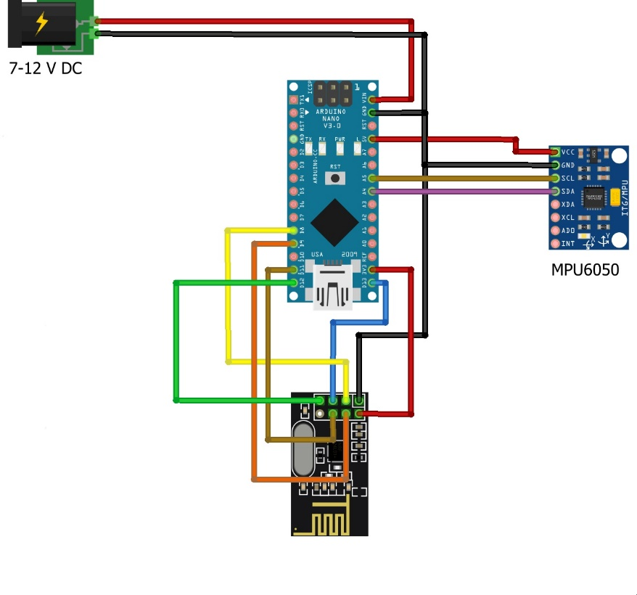

Fig 1: The circuit diagram of the transmitter of hand gesture car.

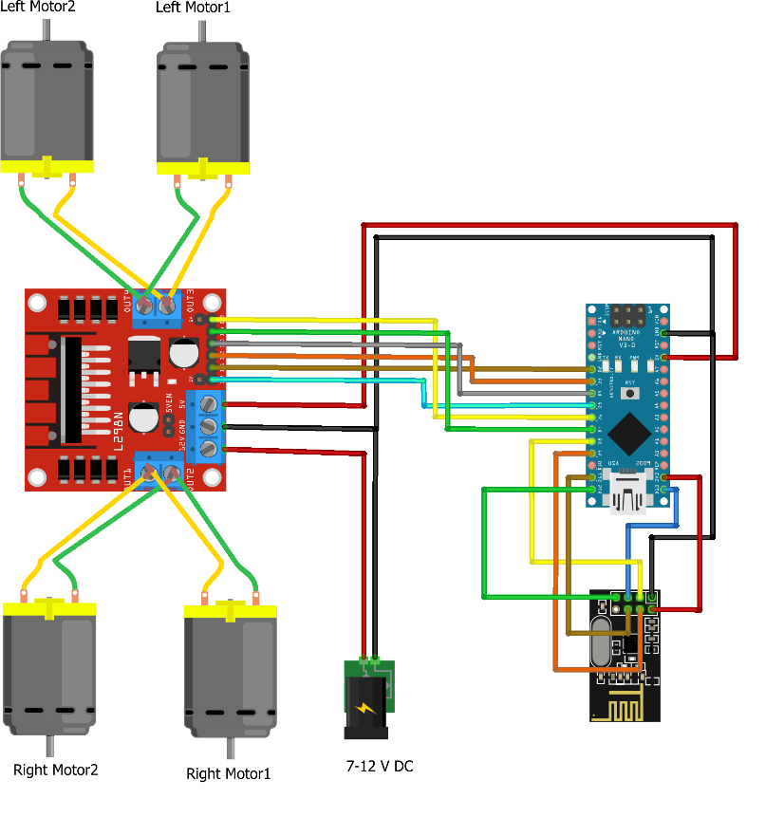

Fig 2: The circuit diagram of the receiver of hand gesture car.

**Working principle:**

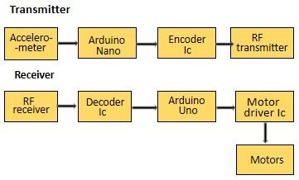This is a project which is based on hand motion or hand gesture technology so as to control an automated vehicle remotely. The hand gesture proposed system is shown in fig 3. At present hand, movement is recognized with help of an accelerometer which is then the simple data passed to the micro-controller to the transmitting side. After processing, information through the accelerometer microcontroller will pass to the remote module and the signal will be a receiver at the receiver part. What's more, from the receiver side microcontroller sense it through the remote module in the accepting receiving wire and passes it to the engines by means of the engine driver. Then the robot wheels will begin to move as directed by the user. Particularly the accelerometer moves in three different directions which is the X, Y, and Z axis in order to get an accurate direction.

Fig 3: The block diagram of hand gesture car. (a) The block diagram of transmitter section for hand-gesture setup. (b) Block diagram of receiver section for robot car setup.

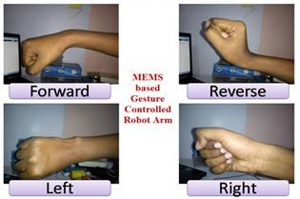

# Fig.4: Movment Signs

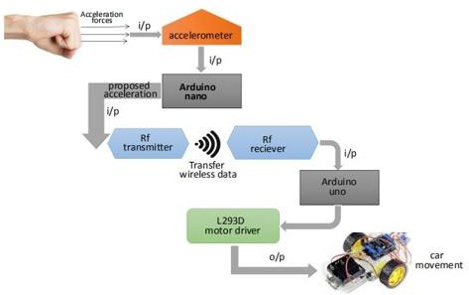Figure 4 shows, There are four hand gestures that can be recognized by the car. They are RIGHT, LEFT, BACKWARD, and FORWARD. The following are the hand gestures used in controlling the car. For effortlessness of analysis, Figure 5 shows the total working and the highlights of the modified hand gesture car. Initially, the accelerometer which is attached to the hand first detects the increasing speed powers from the hand, and later on, it will be sent to the Arduino nano which is connected to the hand. In order to get the information, Arduino Nano changes over it into various point lies between different angles, and this information is received by the RF receiver of the Arduino Uno which is attached to the robot car through the RF sender. Subsequently depending on the information obtained the robot car starts to move in different directions that are forward, reverse, left, and right.

Fig 5: The architecture design of hand-gesture system.

**Cost Analysis:**

|  |  |  |  |  |
| --- | --- | --- | --- | --- |
| **S.L**  **No.** | **Name** | **Price per piece (Tk.)** | **Quantity** | **Price (Tk.)** |
| 1 | Arduino Nano | 750 | 1 | 750 |
| 2 | Nrf 24l01 | 380 | 2 | 760 |
| 3 | MPU 6050 | 500 | 1 | 500 |
| 4 | 7-12 V DC battery and charging port | 90 | 4 | 360 |
| 5 | Driver module L298N | 450 | 1 | 450 |
| 6 | Double sided tape | 60 | 1 | 60 |
| 7 | car kit | 800 | 1 | 800 |
| 8 | Breadboard | 60 | 2 | 120 |
| 9 | Jumper wires | 5 | 50 | 250 |
| Total | | | | 4050 |

**Applications:**

* Wireless Controlled Robots are very useful in many applications like Remote Surveillance military applications, Bomb Diffusion Robots, etc.
* Hand Gestures controlled robots can be used by Physically challenged in wheelchairs
* Hand Gesture controlled industrial grade robotic arms can be developed.
* These robots can also be used on construction Fields and civil works.

**Advantage:**

* Operation Of the system Is simple.
* The production cost of the robot is very low.
* Low Maintenance is Required.
* Operation Is Completely Wireless.
* Simple, Fast and Easy Installation.

**Disadvantage:**

* Irrelevant object might overlap with the hand. Wrong object extraction appeared if the objects larger than the hand.
* Performance recognition algorithm decreases when the distance is greater than 1.5 meters between the user and the camera.
* System limitations restrict the applications such as the arm must be vertical, the palm is facing the camera and the finger colour must be basic colour such as either red or green or blue.
* Ambient light affects the colour detection threshold.

**Limitation:**

* RF module has a limited Range Of operation.
* 9v betteries offer only a limited amount of power to the system.
* No on-board camera for monitoring
* Extreme Heat
* Noise in Bluetooth

**Discussion:**

The purpose of the project is to control a toy car using accelerometer sensors attached to a hand glove. A user can control a vehicle directly by utilizing their hand movements. The sensors are intended to replace the remote control that is generally used to run the car. It will allow us to control the forward and backward, and left and right movements, while using the same accelerometer sensor to control the gesture car based on the hand movements. By using the above-mentioned components the hardware was set up, thus resulting in the formation of a gesture car. The software part was developed in Arduino. The final movement of the robot can be concluded as follows: At the beginning, the robot was in stop mode. As the hand moved from bottom to top, the robot moved in the forward direction. As the hand moved from top to bottom, the robot moved in a backward direction. As the hand was shown at an acute angle towards the left, the robot moved in the left direction. As the hand was shown as an acute angle towards the right, the robot moved in the right direction. As the hand is kept stationary with respect to the environment, the robot was in stop mode. Here, we also added a speed control feature from which we can control the speed of our gesture car. From the experiment, about 100% of the implementation worked according. Hand Gesture Controlled Robot System gives a more natural way of controlling devices. The command for the car to navigate in a specific direction in the environment is based on the technique of hand gestures provided by the user. Without using any external hardware support for gesture input unlike the specified existing system, the user can control a robot from his software Station.

**Conclusion :**

We successfully completed the project and learned how to control a car with the movement of our hand and also the speed control of the gesture car.

**Reference**:

1. Xing-Han Wu, Mu-Chun Su, Pa-Chun Wang. A Hand-Gesture-Based Control Interface for a Car-Robot. Proceedings of 2010 IEEE/RSJ International Conference on Intelligent Robots and Systems, October 18-22, 2010, Taipei, Taiwan.
2. Gordon McAllistel, Stephen, J. McKenna, Ian W Ricketts. Towards a non-contact driver- vehicle interface. Proceedings of 2000 IEEE Intelligent Transportation Systems Conference Proceedings. Dearborn (MI), USA October l-3, 2000.
3. Martin Zobl, Michael Geigel, Bjom Schullec, Manfred Lang, Gerhard Rigoll. A realtime system for hand gesture controlled operation of in-car devices. Proceedings of 2003 IEEE, ICME 2003.
4. David Bannach, Oliver Amft, Kai S. Kunze, Ernst A. Heinz, Gerhard Tr¨oster, Paul Lukowicz . Waving Real Hand Gestures Recorded by Wearable Motion Sensors to a Virtual Car and Driver in a Mixed-Reality Parking Game. Proceedings of the 2007 IEEE Symposium on Computational Intelligence and Games (CIG 2007).
5. Carl A. Pickering, Keith J. Burnhamt, Michael J. Richardson. A Research Study of Hand Gesture Recognition Technologies and Applications for Human Vehicle Interaction. Jaguar and Land Rover Technical Research, UK, Jaguar Cars, Engineering Centre, Whitley, Coventry. Coventry University, UK, Control Theory and Applications Centre, Priory Street, Coventry.
6. Ren C. Luo. Confidence Fusion Based Human-Robot Interaction with Hand Gesture and Emotion Recognition for Service Robotics. Proceedings of CINTI 2012, 13th IEEE International Symposium on Computational Intelligence and Informatics, 20–22 November, 2012, Budapest, Hungary.
7. Sha Zhao, Shijian Li, Longbiao Chen, Yang Ding, ZemingZheng, Gang Pan. iCPS-Car: An Intelligent Cyber-Physical System for Smart Automobiles. Proceedings of 2013 IEEE. DOI 10.11.09
8. Han Jia Qi, Markus Santoso. Immersive Driving Car Simulation for Children using Natural User Interface Controller. Proceedings of 2013 IEEE. DOI 10.11.09/ISUVR.2013.17.
9. Francisco Parada-Loira, Elisardo González-Agulla, José L. Alba-Castro. Hand Gestures to Control Infotainment Equipment in Cars. Proceedings of 2014 IEEE Intelligent Vehicles Symposium (IV), June 8-11, 2014. Dearborn, Michigan, USA.
10. Akshay Dekate, Anam Kamal, Surekha K.S. MAGIC GLOVE- WIRELESS HAND GESTURE HARDWARE CONTROLLER.